Tugas Teori Pengolahan Citra – Latihan 3 Perbaikan Kualitas Citra

Dimas Rizky H.P. – 2110141011 – 3 D4 IT A

1. 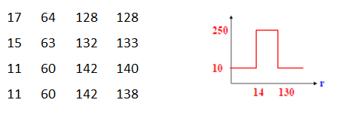Diketahui citra gray level 4 x 4, lakukan transformasi pada setiap piksel mengacu pada fungsi transformasi gray level. Dapatkan citra output hasil transformasi gray levelnya!

***Jawab,***

*Citra Input Citra Output Hasil Transformasi Gray*

|  |  |  |  |
| --- | --- | --- | --- |
| 17 | 64 | 128 | 128 |
| 15 | 63 | 132 | 133 |
| 11 | 60 | 142 | 140 |
| 11 | 60 | 142 | 138 |

|  |  |  |  |
| --- | --- | --- | --- |
| 250 | 250 | 250 | 250 |
| 250 | 250 | 10 | 10 |
| 10 | 250 | 10 | 10 |
| 10 | 250 | 10 | 10 |

1. 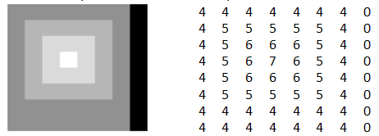Diketahui citra input gray level 8 x 8 dengan range [0 – 7]. Gambarkan histogram citra input. Lakukan ekualisasi dan buat tabelnya, serta dapatkan citra output hasil ekualisasi dan buat pula histogram citra hasil ekualisasi!

***Jawab,***

*Citra Input,*

|  |  |  |  |  |  |  |  |
| --- | --- | --- | --- | --- | --- | --- | --- |
| 4 | 4 | 4 | 4 | 4 | 4 | 4 | 0 |
| 4 | 5 | 5 | 5 | 5 | 5 | 4 | 0 |
| 4 | 5 | 6 | 6 | 6 | 5 | 4 | 0 |
| 4 | 5 | 6 | 7 | 6 | 5 | 4 | 0 |
| 4 | 5 | 6 | 6 | 6 | 5 | 4 | 0 |
| 4 | 5 | 5 | 5 | 5 | 5 | 4 | 0 |
| 4 | 4 | 4 | 4 | 4 | 4 | 4 | 0 |
| 4 | 4 | 4 | 4 | 4 | 4 | 4 | 0 |

*Histogram pada saat input*

*Proses Ekualisasi*

|  |  |  |  |  |  |  |  |  |
| --- | --- | --- | --- | --- | --- | --- | --- | --- |
| Gray level | 0 | 1 | 2 | 3 | 4 | 5 | 6 | 7 |
| No. of pixel | 8 | 0 | 0 | 0 | 31 | 16 | 8 | 1 |
|  | 8 | 8 | 8 | 8 | 39 | 55 | 63 | 64 |
|  | 8/64 | 8/64 | 8/64 | 8/64 | 39/64 | 55/64 | 63/64 | 64/64 |
| S X 7 | 0.875=1 | 0.875=1 | 0.875=1 | 0.875=1 | 4.266=4 | 6.016=6 | 6.891=7 | 7 |

*Citra Output,*

|  |  |  |  |  |  |  |  |
| --- | --- | --- | --- | --- | --- | --- | --- |
| 4 | 4 | 4 | 4 | 4 | 4 | 4 | 1 |
| 4 | 6 | 6 | 6 | 6 | 6 | 4 | 1 |
| 4 | 6 | 7 | 7 | 7 | 6 | 4 | 1 |
| 4 | 6 | 7 | 7 | 7 | 6 | 4 | 1 |
| 4 | 6 | 7 | 7 | 7 | 6 | 4 | 1 |
| 4 | 6 | 6 | 6 | 6 | 6 | 4 | 1 |
| 4 | 4 | 4 | 4 | 4 | 4 | 4 | 1 |
| 4 | 4 | 4 | 4 | 4 | 4 | 4 | 1 |

*Histogram Untuk Citra Ouput*